Julian Gonzalez

CS-2392 Data Structures

10:30-11:50

Lab 1 Recursive Drawing Report

The initial purpose of this lab was for us to get familiar with matplotlib library in python then eventually use that knowledge to create figures all drawn reclusively. We where given 4 different sample figures and out task was to create a program to draw those exact figures but reclusively. The first question has us drawing 5 squares with 4 of them being smaller and in the corners of the main 5th square. My initial solution to this problem was to draw each square separately with all different coordinates and separate recursive calls. The second question was the easiest to do, I used the code provided in the lecture to draw circles and modified only one thing and that was the x coordinate to print by having it subtract radius which would get smaller each recursive call which allowed the circles to have a new origin that would get eventually closer to the edge of the main circle. The third figure Binary trees was implemented in almost the same fashion as the first figure but instead of having 4 recursive calls I would have two, one to draw right trees and one to draw left trees. The last figure I used the center in every recursive call to change the origin point of each circle this involved using the radius which and having that be divided by a third to come up with the figure that was asked of us. I did not implement any input methods for the user the only thing that would happen is the figures would be printed by the IDE and then a .png file was saved on the computer

Experimental results include the changing of values such as n, which was used to determine the amount of recursive calls that would happen. Changing n allowed me to see which number would accurately represent the figures ask from us. This worked out for the most part, A close up of a keyboard
but I had trouble with my first iteration as the my code would not print out the figure correctly 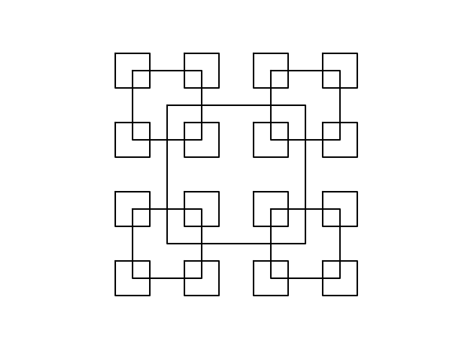and example of failed runs can be see with this figure which is the square one with an n as 15, this would also crash the code was a huge source of grief as I did not know for the longest time that this was the reason why it A close up of a logo
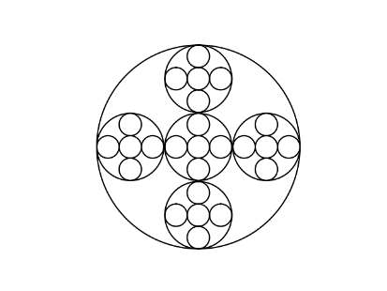did not work, complete and figures are shown below.

I learned a great deal from this project mainly how the matplotlib library works and a greater understanding of recursion and how to implement it in this type of scenario.

Source code: <https://github.com/Gordep/Data-Labs.git>

“I certify that this project is entirely my own work. I wrote, debugged, and tested the code being presented, performed the experiments, and wrote the report. I also certify that I did not share my code or report or provided inappropriate assistance to any student in the class.”